1.import java.io.*;
public class Main
{
public static void main(String[] args)throws IOException
{
BufferedReader br=new BufferedReader (new InputStreamReader(System.in));
System.out.println("Author:J.GOPI VENKATA SAI\nSAP ID:51834677");
System.out.print("Enter a number : ");
int n = Integer.parseInt(br.readLine());
int copy = n, a = 0, sum = 0;
String b = Integer.toString(n);
int len = b.length();

while(copy>0)
{
a = copy % 10;
sum = sum + (int)Math.pow(a,len);
len--;
copy = copy / 10;
}

if(sum == n)
System.out.println(n+" is a Disarium Number.");
else
System.out.println(n+" is not a Disarium Number.");
}
}

OUTPUT:
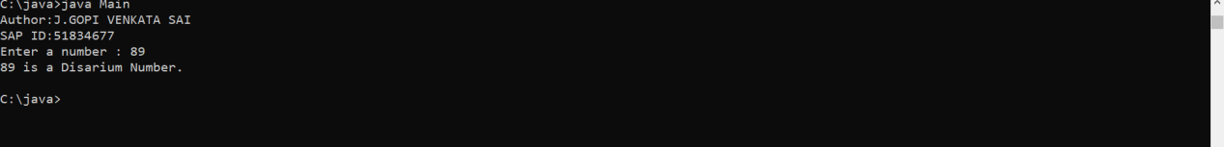

2.import java.util.Arrays;

public class Main
{
private static void sortBinaryArray(int[] inputArray)
{
int zeroCount = 0;

System.out.println("Author:J.GOPI VENKATA SAI\nSAP ID:51834677");
System.out.println("Input Array Before Sorting : "+Arrays.toString(inputArray));

for (int n = 0; n < inputArray.length; n++)
{
if (inputArray[n] == 0)
{
zeroCount++;
}
}

for (int n = 0; n < zeroCount; n++)
{
inputArray[n] = 0;
}

for (int n = zeroCount; n < inputArray.length; n++)
{
inputArray[n] = 1;
}

System.out.println("Input Array After Sorting : "+Arrays.toString(inputArray));
}

public static void main(String[] args)
{
sortBinaryArray(new int[] {1, 0, 1, 1, 0, 1, 0, 0});
}
}

OUTPUT:
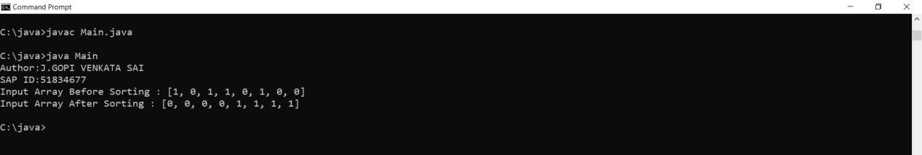

3.import java.util.*;
import java.lang.*;
// Java program to replace a digit
// with other in a given number.
class GFG
{
static int replaceDigit(int x, int d1,
int d2)
{
int result = 0, multiply = 1;

while (x % 10 > 0)
{

// Take remainder of number
// starting from the unit
// place digit
int remainder = x % 10;
// check whether it is equal
// to the digit to be replaced.
// if yes then replace
if (remainder == d1){
result = result + d2 * multiply;
}
else {// else remain as such
result = result + remainder * multiply;
}
// Update and move forward
// from unit place to
// hundred place and so on.
multiply *= 10;
x = x / 10; // update the value
}
return result;
}
// Driver code
public static void main(String[] args)
{
Scanner sc=new Scanner(System.in);
System.out.println("Enter a number:");
int x =sc.nextInt();
System.out.println("enter which no you replace:");
int d1 =sc.nextInt();
System.out.println("enter the number which number you want:");
int d2 =sc.nextInt();
System.out.println(replaceDigit( x, d1, d2));
}
}

OUTPUT:
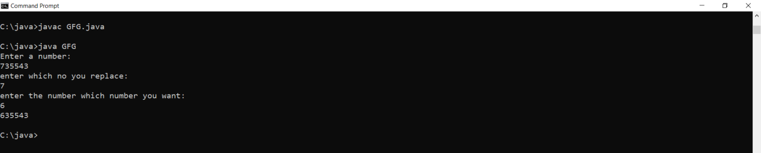

5.public class Main
{
public static int binarySearch(int[] M, int left, int right, int n)
{
if (left > right) {
return -1;
}

int mid = (left + right) / 2;

if (n == M[mid]) {
return mid;
}

else if (n < M[mid]) {
return binarySearch(M, left, mid - 1, n);
}

else {
return binarySearch(M, mid + 1, right, n);
}
}

public static void main(String[] args)
{
int[] M = { 2, 5, 6, 8, 9, 10 };
int key = 3;

int left = 0;
int right = M.length - 1;

int index = binarySearch(M, left, right, key);

System.out.println("Author:J.GOPI VENKATA SAI\nSAP ID: 51834677");
if (index != -1) {
System.out.println("Element found at index " + index);
} else {
System.out.println("Element not found in the array");
}
}
}

OUTPUT:
